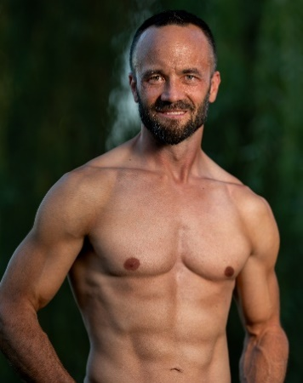
Anderson Talent
5460 W. Franklin Rd. Suite L
Boise, Idaho 83705
208-343-0655

Luke Erickson
Height: 5’8” Jacket size: 39R Hair: Black Eyes: Brown

Film
OUT! Ron NTVI Films
FUBAR Red Rat’s Nest Productions
The Man Who Would Not Shake Hands Captain Capital B Films
The Method Dr. Nelson Senior Film Project: BSU
From Stockton to Table Rock Extra LowerGentry Studios

Commercials
Idaho Lottery: Temple of Tombs Kent NXNW Productions
Ralos: Fred and Mitch Go Solar Fred Fifth Seal Creative LLC

Music Video
James James Taylor Cottonwood Media LLC

Stage
Improv Level 1 performance Self Recycled Minds Comedy
Welcome to the Family Gianni DaRichi Watson’s Dinner Theater
Secret Garden Albert Music Theater of Idaho
Suessical Stage Tech Music Theater of Idaho
Little Women John Brooke Music Theater of Idaho
Shrek Shrek Music Theater of Idaho
Into the Woods Rapunzel’s Prince Music Theater of Idaho

